Worksheet
- Create a Word document:
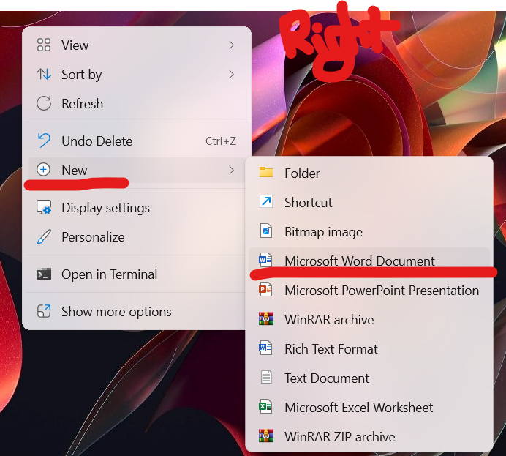
- copy: Right-click the mouse and click copy image
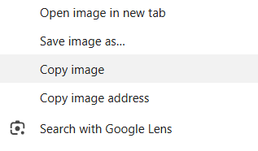
3. Paste
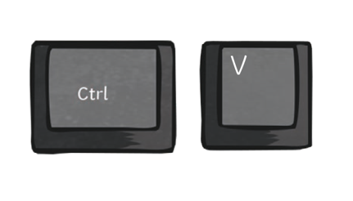
Screenshot
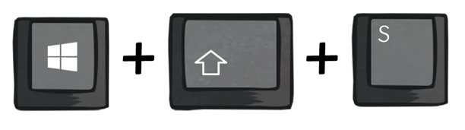
Image | Did you find and copy-paste it?
red
panda
African elephant
giraffe
painted dog
meerkat
narwhal
okapi
capybara

